CERTIFICATE OF ORIGIN

(NON- PREFERENTIAL)
Exporter :  GST |  | Ref: No: DEL -  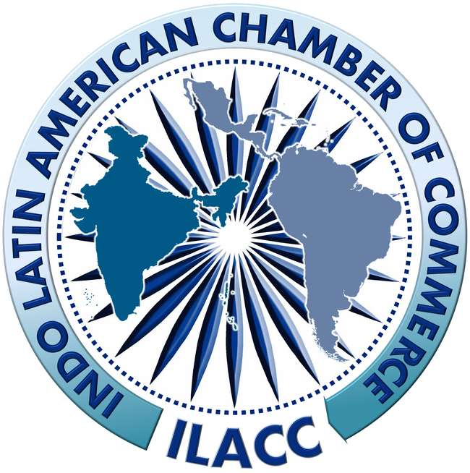  Indo Latin American Chamber of Commerce  Recognized by Government of India (An ISO 9001 : 2015 Certified Organization)  Head Off.: 1008, 10th Floor, B-Block, Naurang House,21, Kasturba Gandhi Marg ,New Delhi-110001, India  Tel: 011-23351541 / 42 / 43, 011-49120292  E-Mail: info@ilacc.com, Website: www.ilacc.com  Corporate Off.: Plot No. 1, Street No.2, MahipalPur Extn, New Delhi-110037 (India),Tel. No. :011-26782744 / 45, E-Mail :vp@ilacc.com  Branch Off: C-62/B, New-147, West Vinod Nagar, Delhi-110092  E-mail:rb@ilacc.com
Consignee :

Notify :

Pre-Carriage by  AIR CARGO | Place of Receipt by Pre - Carriage  AIR CARGO
Vessel / Voyage | Port of Loading  DELHI
Port of Discharge  Netherlands | Final Destination  Netherlands
Marks & Nos./ Container No. No. & Kind of Pkgs. Description of Goods  01  SCARF(COLOUR # MAUVE) |  |  |  | Quantity  179 PCS | Invoice Number, Date & Value  Invoice No:  # AUC-23-007-003  Dated: 03/02/2023  INV. VALUE: €359,79
Certification  It is herby certified that this declaration was made by exporter and that to the best of my knowledge and belief the above mentioned goods are of Indian Origin.  Authorised Signatory |  |  | Declaration by Exporter  We hereby declare that the above mentioned goods were produced /manufactured in India.
Name of the Authorised Signatory

For: _________________

Auth. Signatory:

Signature & Date with Seal

